Intensive Home-Based Services (IHBS) Prior Authorization Request

Web Based Electronic Form-Submission Instructions

As an alternative to faxing requests to (866) 220-4495, Optum is now also accepting IHBS Prior Authorization Requests by web based electronic form submission. Below is the link and instructions to utilize this option.

- Access the IHBS Prior Authorization Request web based electronic form here:
IHBS Prior Authorization Request-Web Based

- Complete all required information, including:
- Prior Authorization Request or Continuing Request check box
- Client Name, Date of Birth, and Client ID
- Program Information (ensure Unit and Subunit are correct)
- IHBS Criteria (items 1-6), check boxes and include date of BHA or Progress/CFT Note, and DSM/ICD Diagnosis.
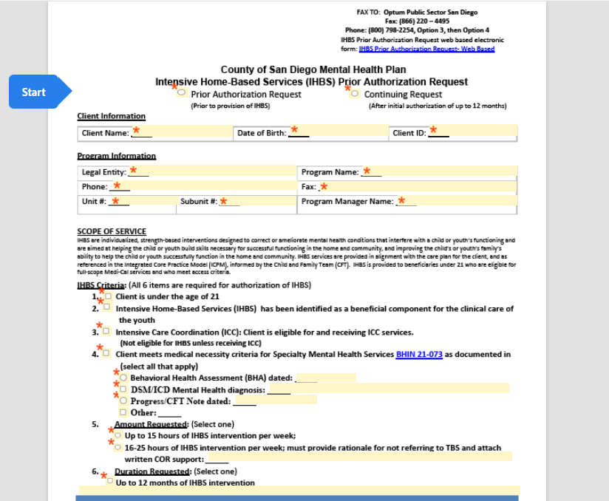

- Once complete, select “Submit” at the bottom of the screen. If applicable, the form may redirect back to areas that are incomplete or need format corrections.

- If prompted, enter a name and an email address associated with the authorization request. Note: If email confirmation of submission is received, this is not the final authorization determination. No emails will disclose any PHI, nor include a copy of your submission.
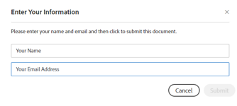

- Next, you will see the below message. A copy of the submitted request may be downloaded at this time; we highly recommend you keep record of the submission.
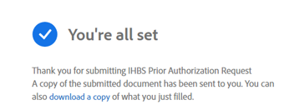

- Authorization determination will be sent from Optum to provider via fax within 5 business days of receipt of complete requests.
- If determination is not received within 5 business days of submission, please contact Optum via telephone Monday-Friday, 8am to 5pm, at (800) 798-2254, Option 3, then Option 4.
- If request is approved, you will receive confirmation via fax.
- If request is denied or modified, you will receive a phone call and a fax with determination and all applicable NOABD paperwork.

- If the need for corrections should arise, Optum will contact the program via phone/fax. A new form will need to be submitted with applicable corrections.

- Please contact Optum Public Sector San Diego via phone at (800) 798-2254, Option 3, then Option 4 Monday-Friday, 8am to 5pm, with any questions.

